Module Name: Manual Test execution
Test Case ID: 6
Webpage URL: https://www.demoblaze.com

Scenario ID: 1

Scenario: Open website
Test Steps:
1. Open the website

Screenshots:
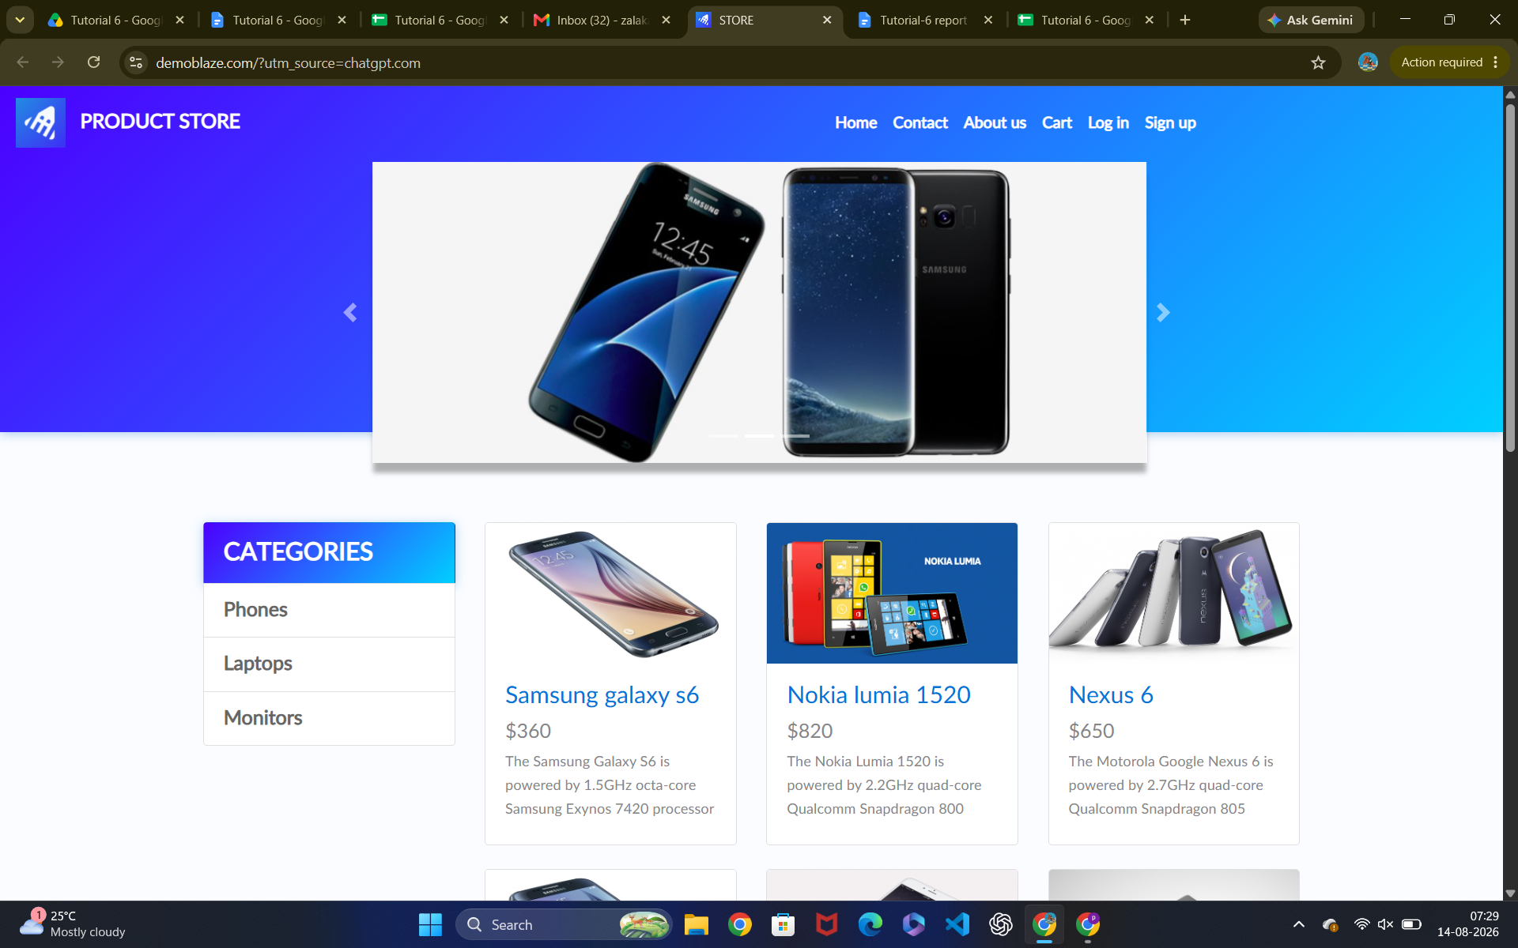Scenario ID: 2

Scenario: select Product
Test Steps:
1. Tap on product you like

Screenshots: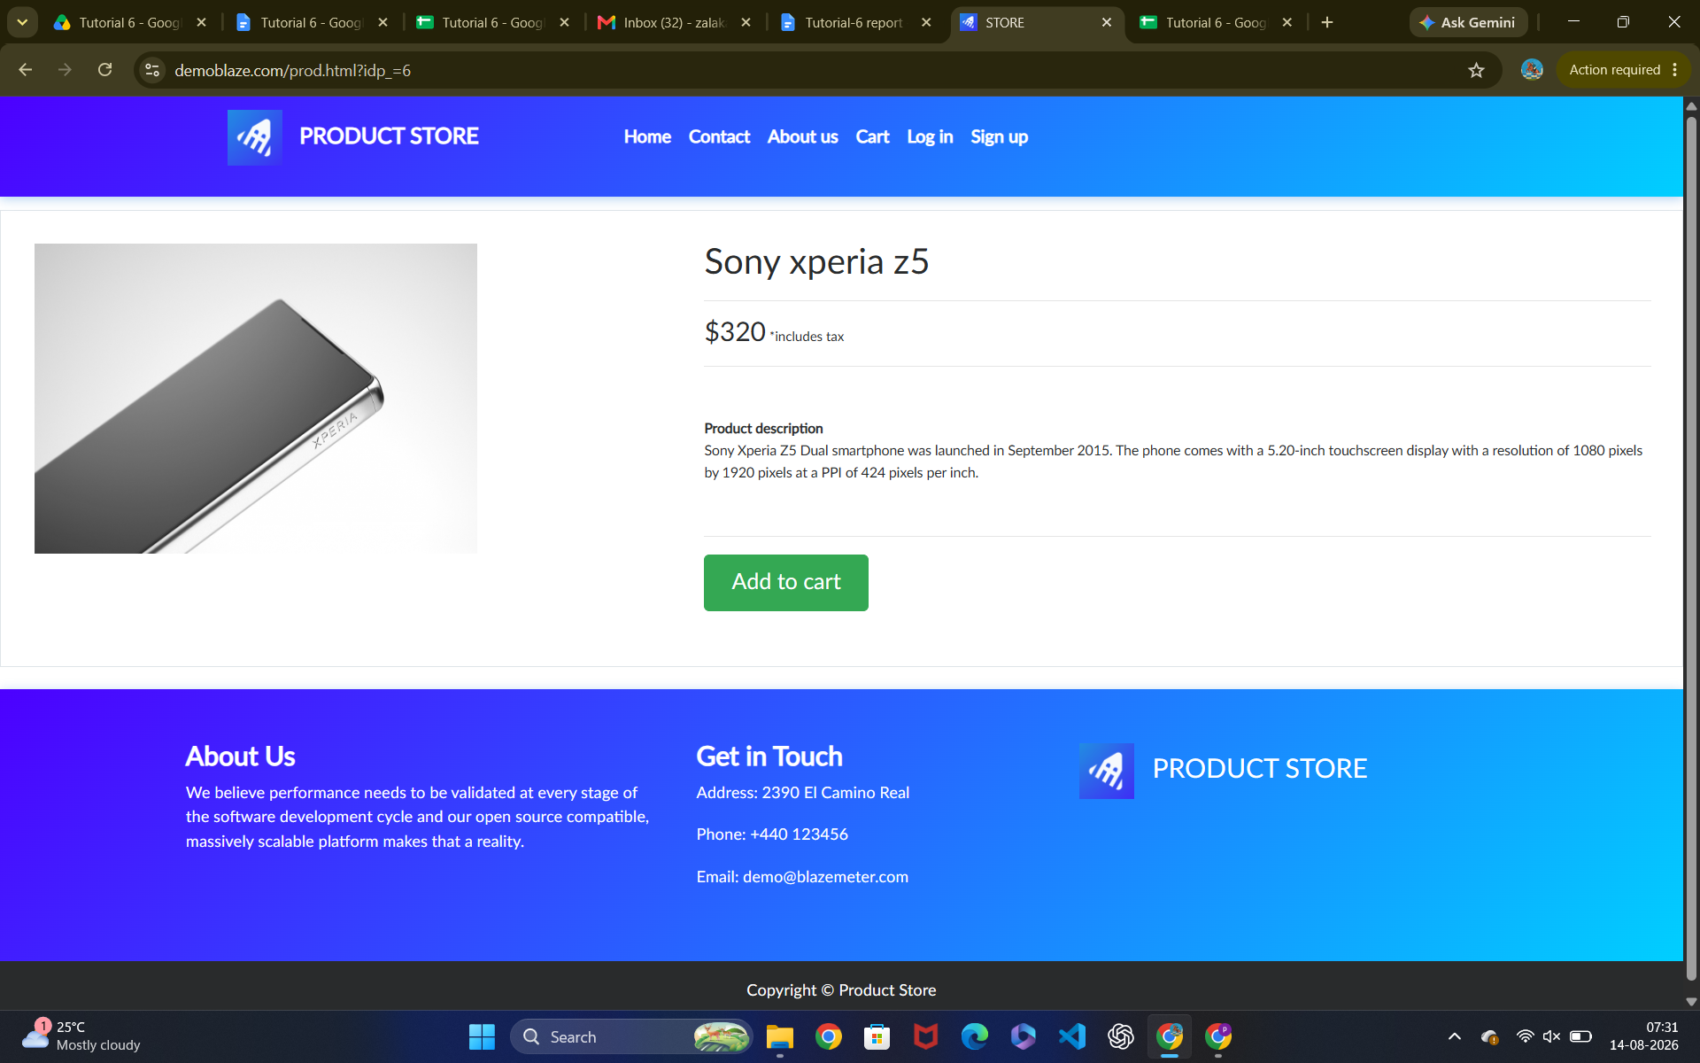Scenario ID: 3

Scenario: Product Details
Test Steps:
1. see product details

Screenshots:Scenario ID: 4

Scenario: Add to cart
Test Steps:
1. Tap on add to cart button

Screenshots: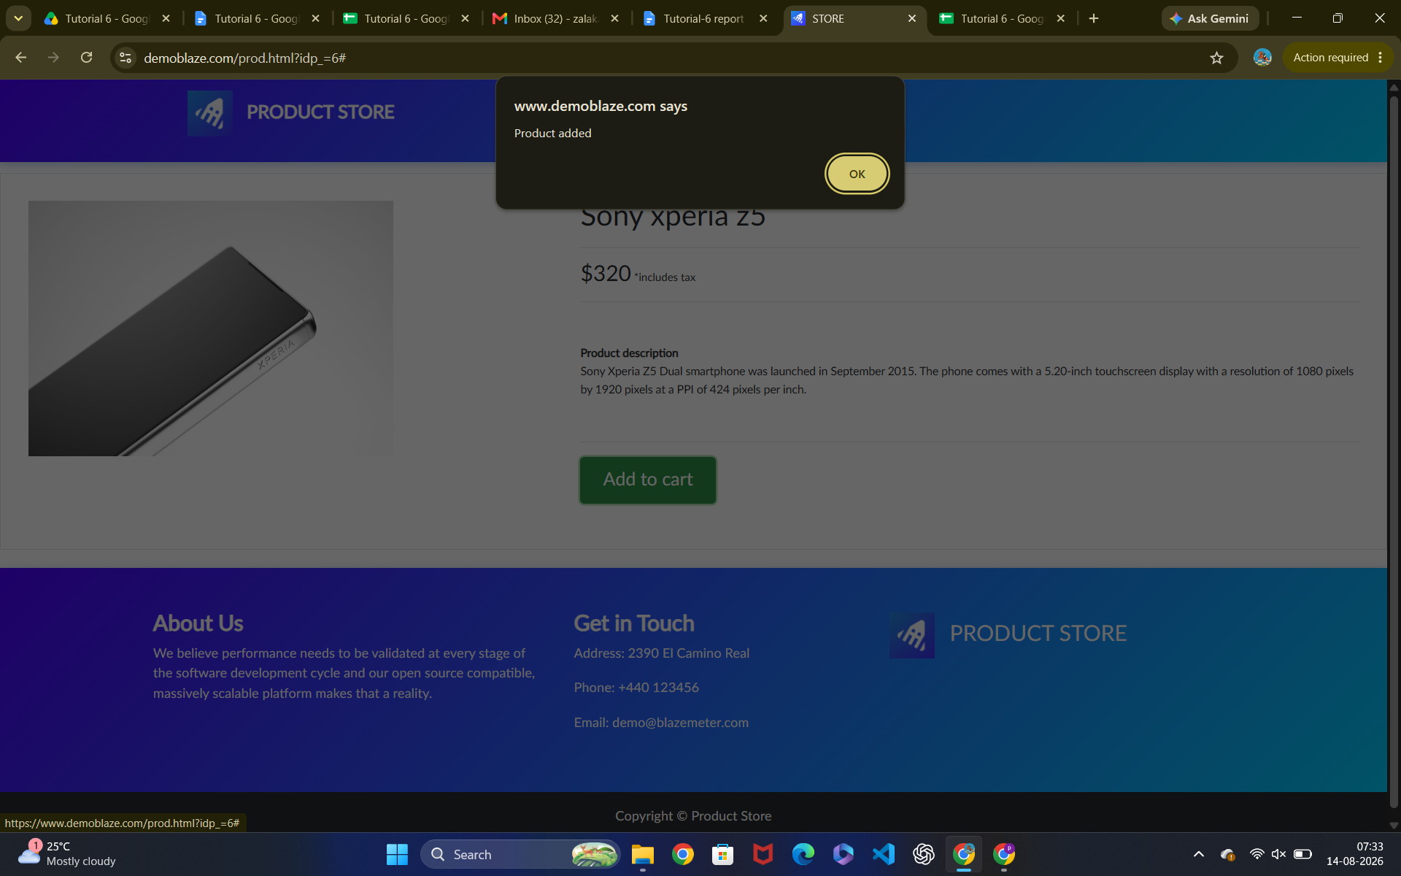Scenario ID: 5

Scenario: cart
Test Steps:
1. Tap on Cart button

Screenshots: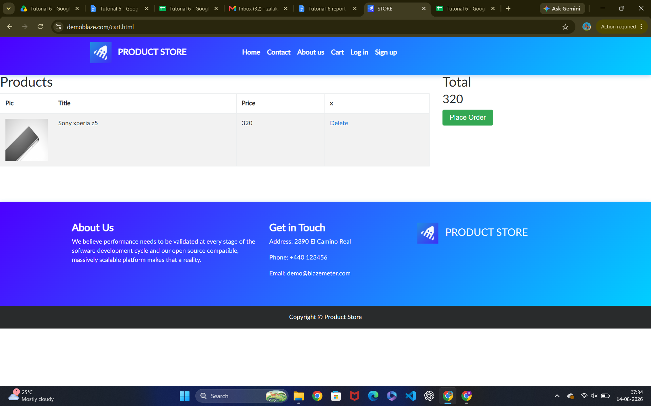Scenario ID: 6

Scenario: Place order
Test Steps:
1. Tap on place order button

Screenshots: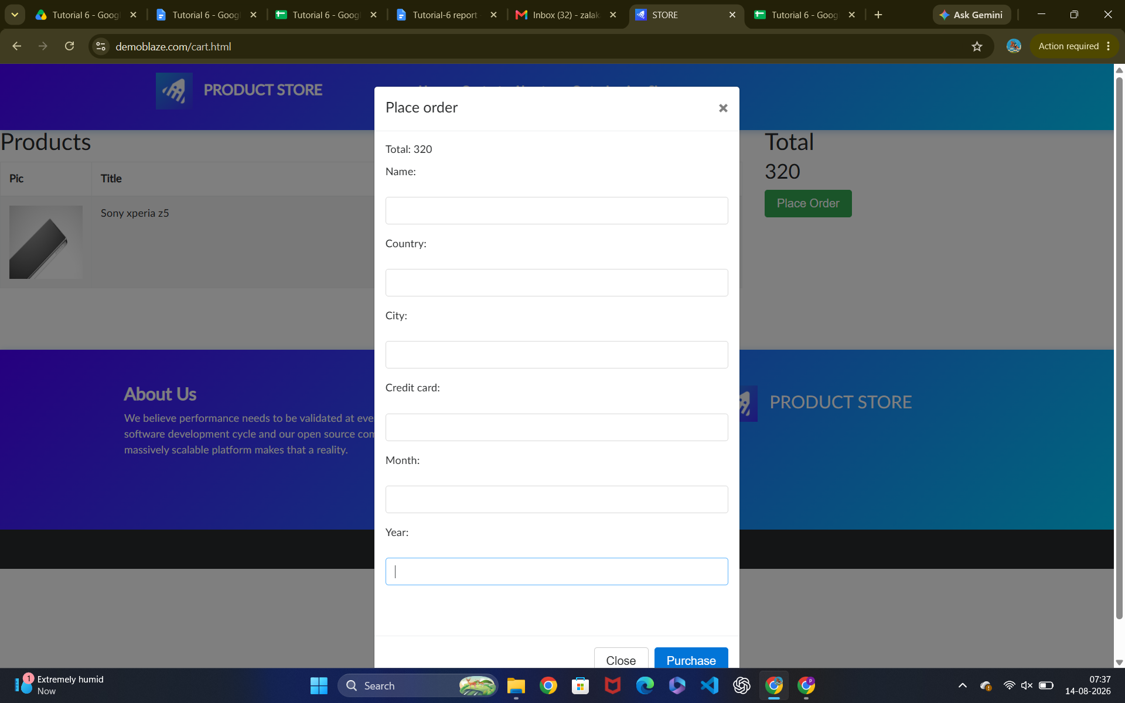Scenario ID: 7

Scenario: Customer details
Test Steps:
1. Enter Name
2. Enter country
3. Enter City
4. Enter Credit card
5. Enter Month
6. Enter Year

Screenshots: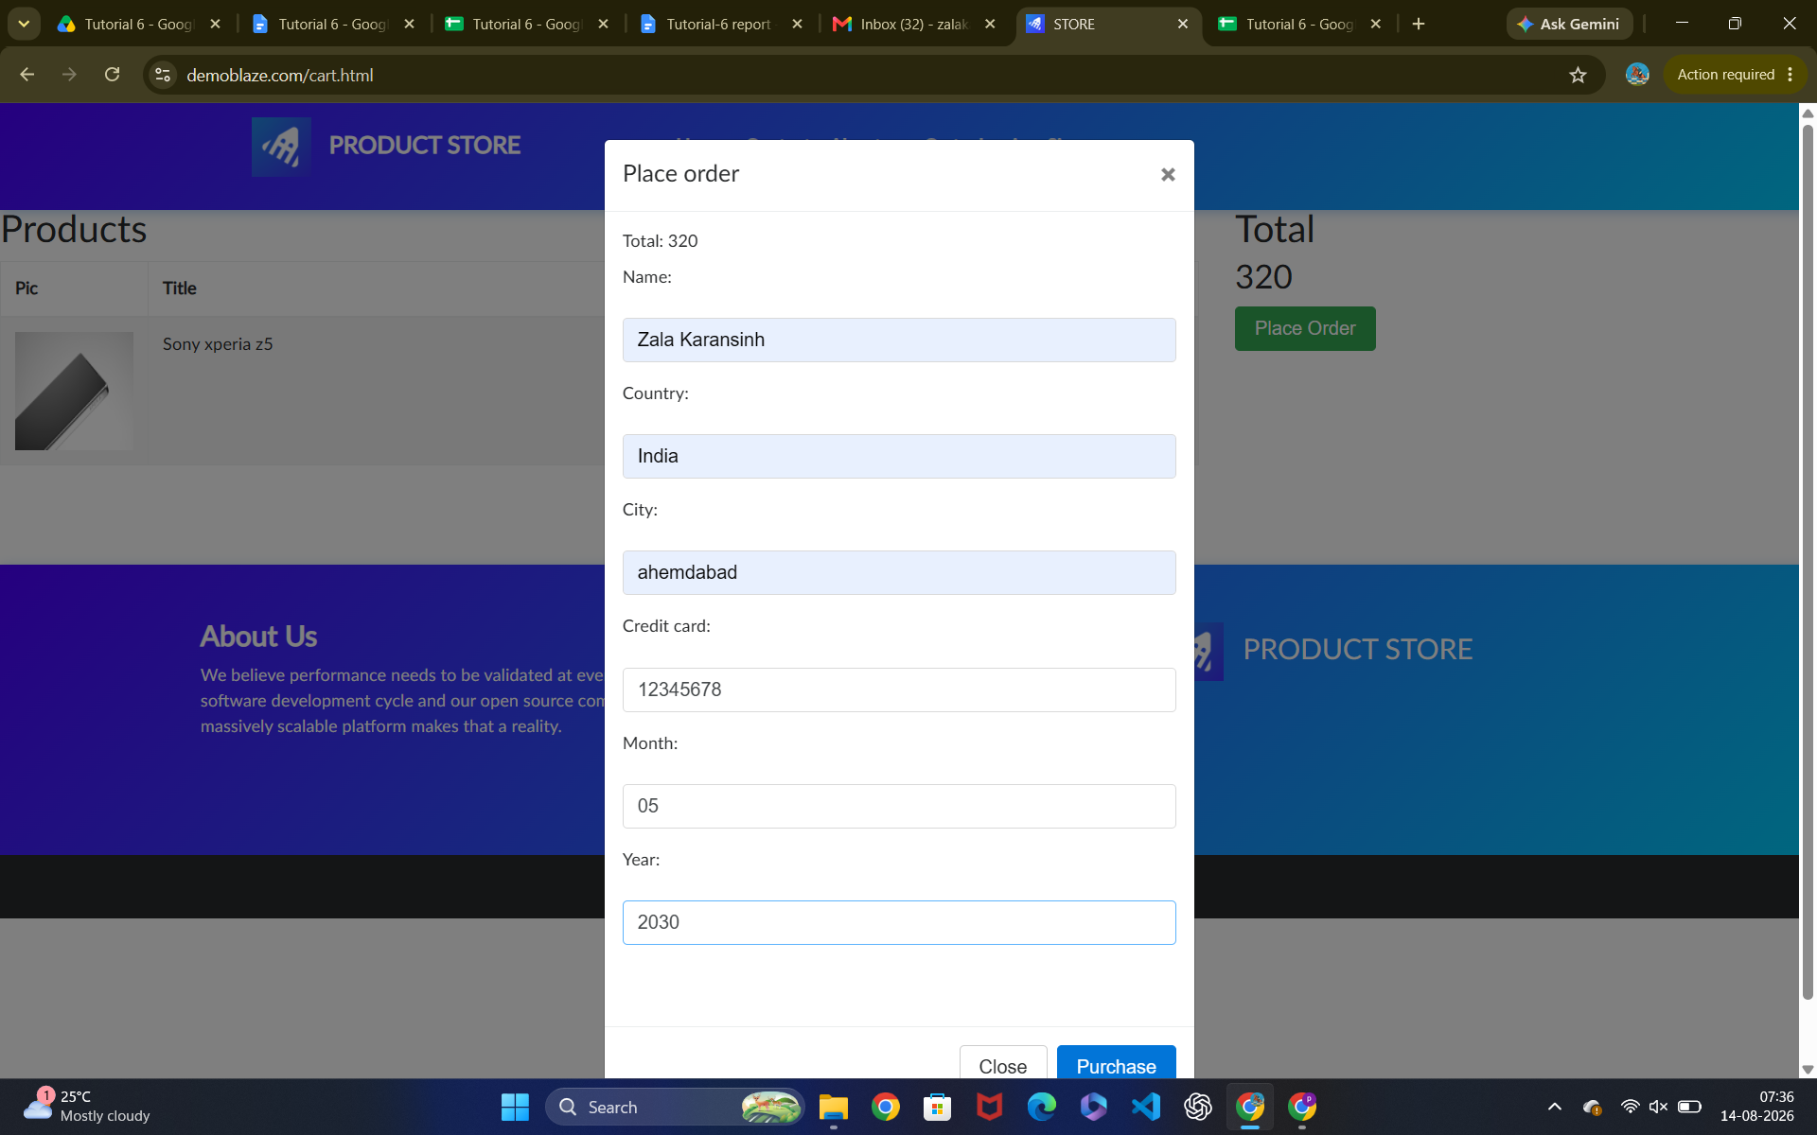Scenario ID: 8

Scenario: Submit order
Test Steps:
1. Tap on purchase button

Screenshots:

